[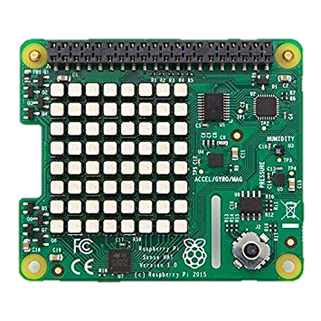](https://www.google.com/url?sa=i&rct=j&q=&esrc=s&source=images&cd=&cad=rja&uact=8&ved=&url=https://www.amazon.co.uk/Raspberry-Pi-FBA_2483095-Sense-HAT/dp/B014T2IHQ8&psig=AOvVaw2Qf3z2UYl7xRJmgjBt_7zc&ust=1553951766878158)[](https://www.google.com/url?sa=i&rct=j&q=&esrc=s&source=images&cd=&cad=rja&uact=8&ved=2ahUKEwicvoWTtafhAhUN1uAKHTrBAGoQjRx6BAgBEAU&url=https://www.vectorstock.com/royalty-free-vector/cartoon-jungle-game-background-vector-8536993&psig=AOvVaw2263DB58o3PtvMDSgpe8k-&ust=1553950973953478)Crash Landing – part 1

[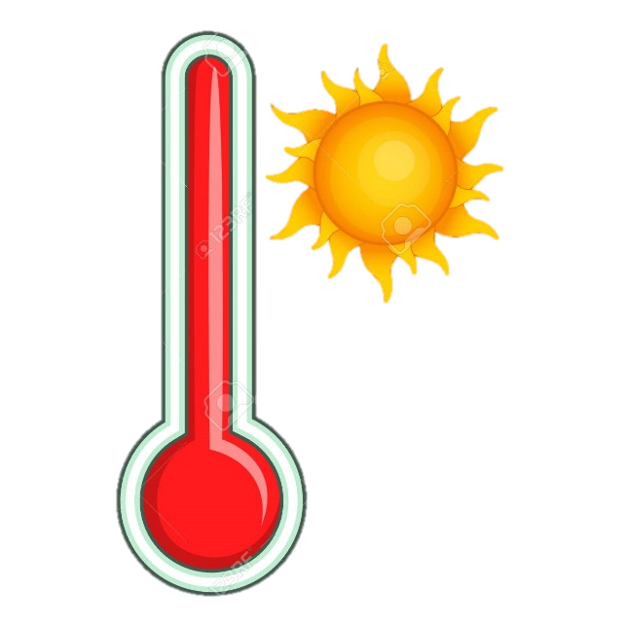](https://www.google.co.uk/url?sa=i&rct=j&q=&esrc=s&source=images&cd=&cad=rja&uact=8&ved=2ahUKEwjW4qiPtqfhAhX5gM4BHVJ5AtsQjRx6BAgBEAU&url=https://www.123rf.com/photo_67219927_stock-vector-thermometer-icon-cartoon-illustration-of-thermometer-vector-icon-for-web-design.html&psig=AOvVaw3-STyafP1OVdGd_652BmTM&ust=1553951332894674)

**Task 1 – Is it too hot or cold in the jungle?**

from sense_hat import SenseHat

sense=SenseHat()

temp = sense.temp

print(temp)

temp = round (temp,2)

print (temp)

if temp < 10:

print ("Warning too cold - risk of hypothermia")

elif temp >38:

print ("Warning too hot - risk of hyperthermia")

else:

print ("Safe temperature")

**Task 2 – is it going to rain?**

from sense_hat import SenseHat

from time import sleep

sense = SenseHat()

r=[255,0,0]

sense.clear()

while True:

for c in range (0,7):

pressure = sense.pressure

print (pressure)

graph_pressure = int(pressure / 150)

print (graph_pressure)

for i in range(graph_pressure):

sense.set_pixel(c,i,r)

print (c)

sleep(300)

sense.clear()